**Lab # 11**

**Object:**

Introduction to Design Patterns and understanding the Facade Pattern .

Example of a System: (**Façade Pattern)**

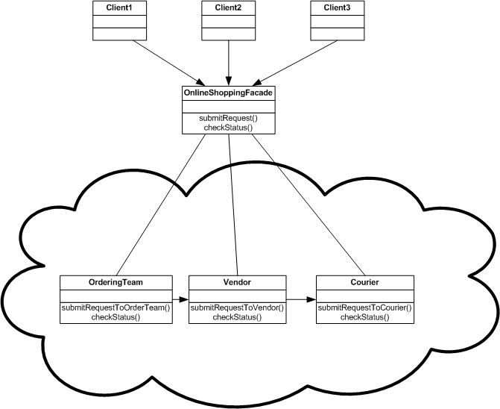

**THE INTERNAL PROCESS** that is hidden from the Client:

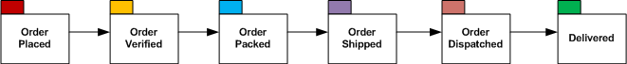

Why we need a **FAÇADE** for this system?

Basically the example works like this. (Online Shopping Façade) is the interface which is exposed to the customers (us). It's just like any portal like Flipkart, Amazon or eBay. Now we do not know what the heck is going behind those websites. All we know is that we have just placed an order and we will get a delivery after a certain period of time.

**KEY FEATURES** with respect to the example, given above:

* The intricacies behind the process is hidden away from us. This is the Facade for the Online Shopping Portal.The client just deals with the exterior.The façade pattern keeps the client away from the internal processes.
* OnlineShoppingFacade provides an interface which hides the internal complexity of a system.
* It only exposes the desired interfaces which have to be used by a client.